University Of Engineering and Technology, Lahore
Computer Engineering Department

Course Name: Programming Fundamentals | Course Code: CMPE-112L
Assignment Type: Lab tasks | Dated: 23 March 2026
Semester: First | Session: 2026 Spring
Lab/Project/Assignment #: 1 | CLOs to be covered: CLO 1
Lab Title: Nested Loops | Teacher Name: Hafiz Muhammad Mubashar
Lab Evaluation:

CLO1 | Apply appropriate programming techniques to create executable programs to solve well defined problems
CLO1 | Level1 | Level2 | Level3 | Level4 | Level5 | Level6
(5)
Total |  |  |  |  |  | /5
Rubrics for Current Lab Evaluation
Scale | Marks | Level | Rubric
Excellent | 5 | L1 | Submitted all lab tasks, BONUS task, have good understanding.
Very Good | 4 | L2 | Submitted the lab tasks but have good understanding
Good | 3 | L3 | Submitted the lab tasks but have weak understanding.
Basic | 2 | L4 | Submitted the lab tasks but have no understanding.
Barely Acceptable | 1 | L5 | Submitted only one lab task.
Not Acceptable | 0 | L6 | Did not attempt
Week 4 LAB
Nested Loops
Lab Goals/Objectives:
• To understand and implement nested loops (loops inside loops) using both for and while structures in Python.
• To master coordinate tracking and grid-based logic using outer loop (i) and inner loop (j) variables.
• To generate complex geometric text patterns, pyramids, and inverted shapes through algorithmic whitespace and character printing.
Equipment Required:

* Computer/Laptop
* Python 3.14
* VS Code or pycharm

Theory:
Nested loops consist of an outer loop and one or more inner loops. Each time the outer loop runs once, the inner loop executes completely through all of its iterations.

Lab Work:

Task 1: Multiplication Matrix Generation

for i in range(1, 5):
for j in range(i):
print(i * j)
Result:

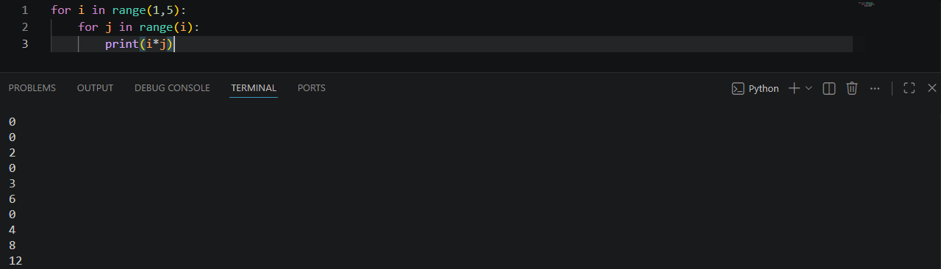

Task 2: Standard Left-Aligned Triangle Pattern

for i in range(6):
for j in range(i):
print("*", end="")
print()

Result:
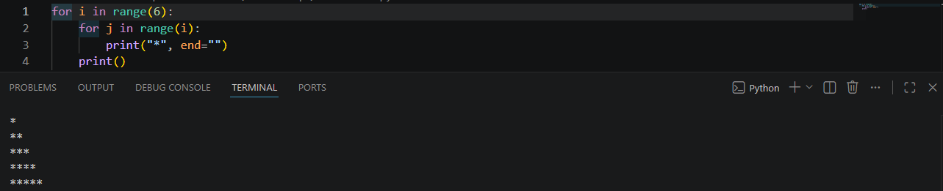

Task 3: Nested Loop Coordinate Tracking (Rows and Columns)

for i in range(6):
for j in range(i):
print("i=", i, "j=", j)
print("----")

Result:
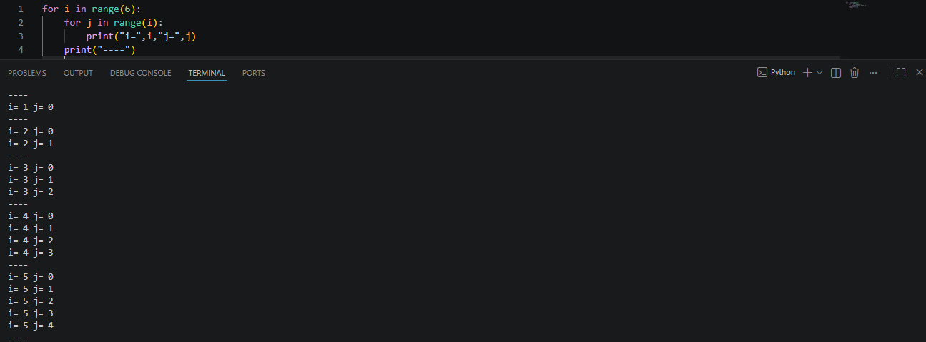

Task 4: Explicit Tuple Mapping (Vertical Layout)

for i in range(1, 4):
for j in range(i):
print("(", i, ",", j, ")", end=" ")
print()

Result:

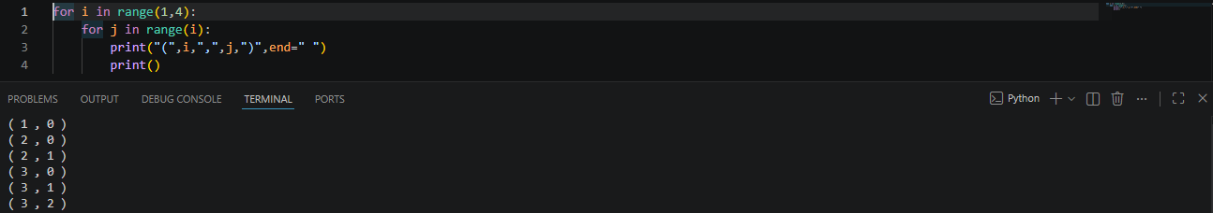

Task 5: Dynamic Row-Column Boundaries (Offset Matrix)

for i in range(1, 4):
for j in range(i + 1):
print("(", i, ",", j, ")", end=" ")
print("i", end=" ")

Result:
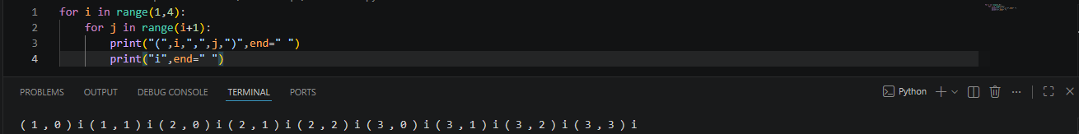
Task 6: Inverted Inverted Number Block (Shrinking Rows)

for i in range(1, 5):
for j in range(5 - i):
print("1", end=" ")
print()

Result:
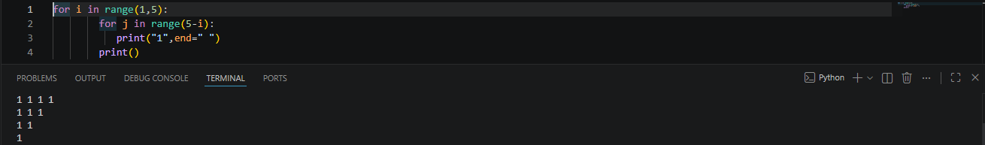

Task 7: Symmetrical Star Pyramid (for loop approach)
for i in range(1, 5):
for j in range(5 - i):
print(" ", end="")
for k in range(2 * i):
print("*", end="")
print()

Result:
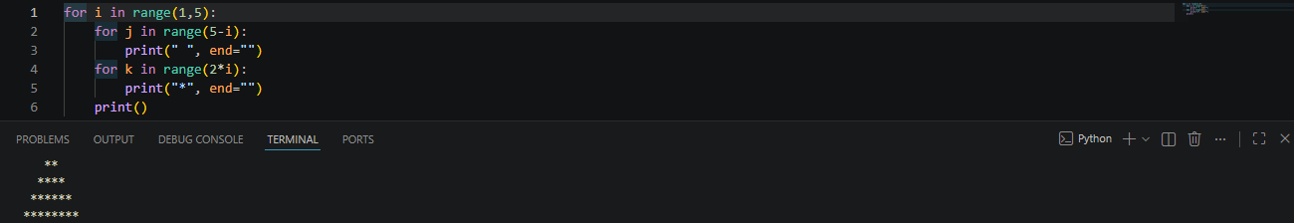

Task 8: Symmetrical Star Pyramid (while loop approach)
while i <= 4:
while j < (4 - i):
print(" ", end="")
j = j + 1
while j < (2 * i - 1):
print("*", end="")
j = j + 1
i = i + 1

Result:

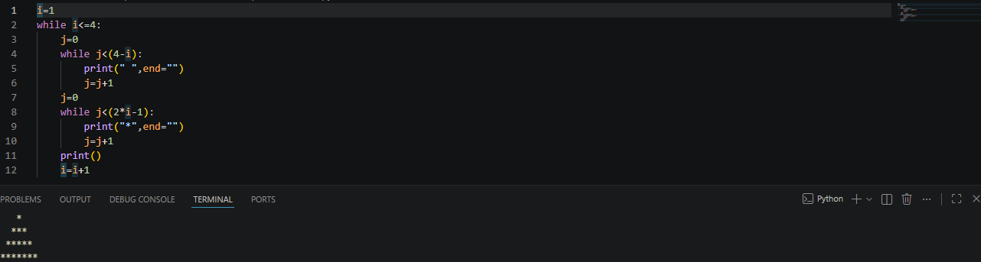

Conclusions:
This lab successfully demonstrates how nested iteration controls multidimensional outputs. By manipulating the execution bounds of an inner loop relative to its outer loop, we can systematically plot mathematical grids, track strict index steps, and calculate whitespace geometry to build both simple blocks and complex centered pyramids.

